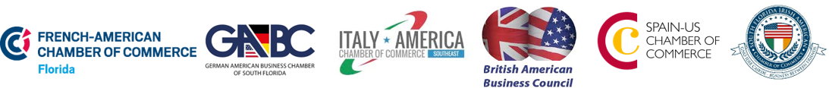
TECHNOLOGY SEMINAR

CONQUERING NEW MARKETS
SPONSORSHIP FORM:
EXHIBITOR’S PACKAGE INCLUDES:
- Brief presentation about your company during the seminar (1 min.)
- Logo Exposure in the event communications:
- Company logo on seminar’s invitation sent out to all European Chambers’ contacts (17,000+)
- Mention in the dedicated post of the event on European Chambers’ social media platforms
- Company description listed in the Sponsors list on the European Chambers’ website plus link to your company’s website
- Display table for networking activity during cocktail
- Display of marketing materials: possibility to bring your own visual support + distribution of marketing tools

EXHIBITOR FEE: $400
Participating Company:
Address:
City/State/Zip:
Phone:
Email:
Website:
Exhibiting Representatives (2):
Brief company description to be used in the events communications (max 30 words):
*Please provide your company’s logo in HD PNG format.

PAYMENT METHOD
CHECK
Please, remit check to:
Italy-America Chamber of Commerce Southeast
999 Brickell Avenue suite #1002, Miami, FL 33131 or by Fax at 305-577-3956
CREDIT CARD type:_________ CC Number _____________________ Exp. Date:_______ CVC:_____
Cardholder’s name:____________________________Signature:____________________Date:_________

