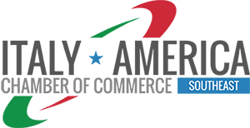

2019 CANDIDATE STATEMENT FOR
ITALY-AMERICA CHAMBER OF COMMERCE SOUTHEAST, INC.

This statement must be received in the Chamber Office by 5:00 p.m., EST, Miami, Friday, May 17th, 2019; by e-mail to info@iacc-miami.com (subject: Att. Compliance Committee). Any additional information of qualifications or objectives shall be limited to one (1) attached “Annex A” page (Font to use: Arial 11). Please ask a confirmation of receipt when presenting your statement for candidate.

1) NAME OF CANDIDATE:

2) IACCSE MEMBER CONTACT PERSON SINCE (DATE) (YY/MM):

3) CURRENT EMPLOYER:

4) POSITION WITH CURRENT EMPLOYER:

ANNEX A

PROFESSIONAL EXPERIENCE OF THE CANDIDATE - INCLUDING IACCSE ACTIVITIES AND COMMUNITY PARTICIPATION (max 250 words; Arial 11)

OBJECTIVES/PROPOSALS OF THE CANDIDATE (max 250 words; Arial 11)

